Current Market View – February 2026

Investment Markets
Global Markets
Global markets in February 2026 were generally steady, with a noticeable shift in leadership away from the big U.S. tech names that had long dominated. Investors became more cautious about the heavy spending required for AI infrastructure, which took some shine off the major US indices. In contrast, markets in Asia and emerging economies enjoyed a stronger month, helped by calmer bond markets and a more optimistic outlook for global growth.
Late-month geopolitical tensions briefly unsettled investors, but they didn't derail the broader mood. Traditional safe-haven assets like gold and silver surged as people sought protection, while sectors such as energy and utilities held up well. Overall, February felt like a month when markets were adjusting and moving away from a narrow, tech-driven rally and broadening into other regions and sectors.

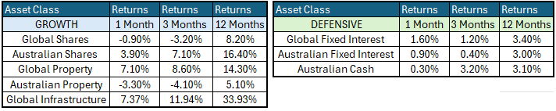

Global Share Markets
Global share markets were up in February, after a strong start to the year in January, and following three great years of returns in 2023-4-5. All sectors did well in Feb, apart from software firms, which were hit by fears that AI would destroy their business models. As a result, the U.S. was the only major market to post a decline in Feb while the rest of the world was strong.
Amazon was down -12%, Microsoft -9%, Meta/Facebook -10%, Alphabet/Google -8%, Palantir -6%, Adobe -11%, Oracle -12%, and also spread to integrators like IBM -22%. Tesla was down another -6% (but mainly due to car troubles). The AI rout also extended to Chinese stocks like Alibaba (-16%), Tencent (-15%), and Baidu (-19%).
Also being hit by AI bubble fears were several U.S. financial stocks, with rising concerns over exposures to private credit lending to AI firms and data centres, both directly and indirectly via hedge funds, venture capital, and retail private credit funds. This space is riddled with related-party transactions, concocted accounts, and fudged valuations, so nobody actually knows where potential losses are.
But more than offsetting these losses were strong gains elsewhere – including consumer staples (with strong consumer spending still), fossil fuels (oil price spike on Middle East war fears), healthcare, industrials, and industrial materials.
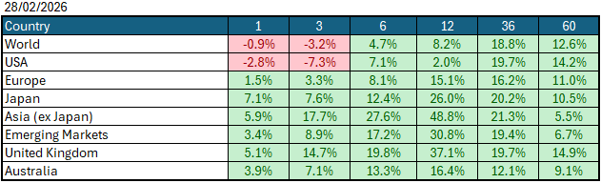
Data Source: AFM as of February 28 2026.

Global Bond Markets
Bond markets posted small gains as yields fell worldwide amid fears of slowing growth, perhaps reflecting concern about U.S. deflation, unemployment, and business failures as AI devastates companies and jobs. However, this outlook is inconsistent with current strong job markets, consumer spending, and corporate profits, although these are backward-looking measures, whereas bond yields are forward-looking. Slowing growth outlooks are also inconsistent with credit spreads, which widened a fraction in February but remain very tight, leaving little room for corporate failure.
Interest rate markets in the U.S. and the UK eased over January 2026, with the 10-year Government bond rate decreasing to 4.004%. UK 10-year Gilts were trading at 4.378% on January 31 2026.
Domestic Bond Markets
Treasury yields rose across all maturities in Australia as markets priced in rate hikes and sticky inflation. For Australia, the latest inflation prints for (year-on-year) January 2026 remained in line with the December print of 3.8%. The RBA board is set to meet on the 16th/17th March 2026, with market pricing giving a 50:50 chance of a +25bps rate hike to 4.10%.

Investment Climate
U.S. equities ended January 2026 on a positive note, beginning the year off on the right foot, lifted by the outlook for more Federal Reserve rate cuts and higher company profits. The U.S. reporting season for Q4 2025 was mostly good, with more beats than misses. Share markets rose across the board, except in the U.S., where software stocks dragged down the index's return amid continued fears that AI would destroy revenue streams. There has been a dramatic shift away from 'asset-lite' companies to companies with hard assets.

Medium-term investors are encouraged by the anticipated gradual easing of interest rates; however, the unsettled nature of the share and bond markets clouds the short-term direction. Soft-landing expectations and economic recovery are still supported by the data, despite recent volatility.
The medium-term view remains positive for returns, as U.S. Fed Chair Jerome Powell appears to have shifted his stance toward further U.S. interest rate easing in 2026. At the January 2026 Meeting, the Fed held interest rates at 3.75%, with the market anticipating one of two more interest rate cuts later this year. With Kevin Warsh being named Federal Reserve Chairman, the market is still expecting interest rate cuts despite potential inflation increases.
Long-term investors are optimistic about a recovery period ahead. Global central banks continue to indicate a resolve to get inflation under control; however, economic data is showing signs of stabilisation despite elevated inflation, and every indication is that future monetary policy easing is possible in 2026.
The following commentary is based on month-end closing prices as of February 28, 2026:
Global share markets were stronger in January, with Japan, China and South Korea outperforming the U.S. and European markets, following a surge in macroeconomic news from the USA. The AUD/USD strengthened from 0.6963 to 0.7116 (+2.2%).
The U.S. Fed held the federal funds rate target range at 3.50%-3.75% when it met on the 27th/28th January 2026. Investors are gaining more confidence that the economy is headed for a soft landing despite the intermittent bouts of volatility. The next Fed meeting is on the 17th/18th March 2026.
The underlying short-term theme is "risk-on" for shares.
The situation in the Russia/Ukraine conflict remains unchanged, with the latest conflict between Israel and Gaza (Hamas) remaining unchanged as well. Volatility increased as the USA/Israel moved towards a war with Iran.
Investor Focus
For Australia, investors focused on the following issues:
- Cost of living expenses and the impact on consumer spending.
- Commodity prices (post-China policy changes) and the impact on company profits.
- The level of interest rates and the delicate position of the RBA, given the global volatility in markets.
- Rising Oil Prices as conflicts with Iran escalated
- U.S. tariffs and the impact on Australia's exports (if any).
- Inflation (year-over-year) remained flat at 3.8% in December, with the next quarterly CPI being released on April 29, 2026.
- Government spending and the rising debt level.

Currency
The Australian Dollar closed stronger, AUD/USD 0.7116 at the end of February 2026, up from 0.6963. This followed the Fed keeping rates on hold during the month and macroeconomic data in Australia pointing towards a rate hike in March.

Currency forecasters see the AUD/USD range between:
0.65 and 0.75 cents in the medium term and most likely to trade within the:
0.5500 to 0.7500 range in the longer term.

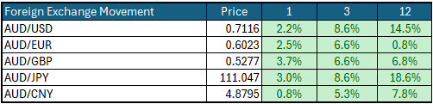

Australian Economy
Australia's latest GDP data for the final quarter of 2025 showed an annual growth rate of 2.6%, up from 2.1% in the third quarter of 2025. Unemployment remained steady at 4.1% in January 2026. The year-over-year (Y-O-Y) inflation rate also remained steady at 3.8% in January 2026, but remains outside the Reserve Bank's targeted 2% to 3% inflation range and could lead to a rate hike in March.

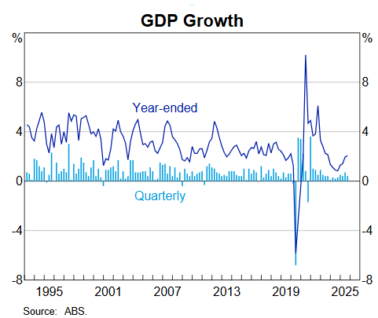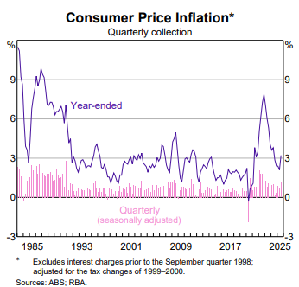

Current Market View

Domestic View
The overall investment view for shares is "risk-on" over the short term, "cautiously optimistic" over the medium term, and "long run" as corporate profits continue to grow faster than inflation and the need to build out data centres to drive commodity prices.
The market is currently 50:50 on an interest rate hike on the 16th/17th of March 2026, due to a "hotter" inflation print in December that showed inflation is now outside the RBA's target range of 2-3%.

Global View
The global share market remains optimistic, supported by the Fed, which is likely to cut interest rates once more in 2026. Inflation could spike following an increase in oil prices, given tensions in the Middle East and the fact that tariffs haven't fully impacted the economy. GDP remains strong in the U.S. as AI infrastructure investment continues to boost spending nationwide.

Where to From Here?
- Continued shift from rules-based order and win-win multi-lateral trade to power-based order and win-lose trade deals. Trump did not start this. The shift started in the 2010s with the U.S./Europe letting Putin take Crimea in return for cheap gas for Germany/Europe, and the U.S./Japan letting China militarise the South China Sea. It has certainly accelerated under Trump. Lower cross-border trade & investment, more reliance on government subsidies & distortions, and inflationary onshoring of uneconomic industries.
- Sticky inflation - political pressure on central banks to keep rates low – populist pressure on governments to keep deficit spending. Tariffs + onshoring adding to costs/prices. Bond yields to stay elevated or even drift higher, risk of bond yield spikes, or a sudden need for rate hikes, unsettling / breaking share markets.
- Share markets continue to be supported by good profit growth for now. Shares everywhere are expensive, but buoyed by loose monetary & fiscal policies, plus a near-certainty that governments will throw 'free'/borrowed money at any problem.
- Commodities rally gathering pace – rising demand soaking up oversupply, AI/data centre boom (industrial metals, energy, water, land), global rearmament – especially Europe, Japan, Canada. This should support the ASX market, as long as banks avoid a local recession.
- De-dollarisation fears are probably overdone, but are driving up gold and silver, not bitcoin. U.S. Treasury yields are not at risk for now (and even fell in February).
- The current boom will end one day, of course. All markets everywhere, including and especially Australia, are over-priced on fundamentals, not just U.S. big tech. However, each boom is different, and the triggers for the inevitable bust are different each time.

This document is issued by Atlas Funds Management Pty Ltd. Atlas Funds Management Pty Ltd does not provide any general advice or personal advice regarding any potential investment in any financial products within the meaning of section 766B of the Corporations Act. No consideration has been made of any specific person's investment objectives, financial situation or needs. The provision of this presentation is not and should not be considered as a recommendation in relation to an investment in any entity or that an investment in any entity is a suitable investment for any specific person. Recipients should make their own enquiries and evaluations they consider appropriate to determine the suitability of any investment (including their investment objectives, financial situation, and particular needs) and should seek all necessary financial, legal, tax and investment advice. Atlas Funds Management Pty Ltd, it's directors and employees do not accept any liability for the results of any actions taken or not taken on the basis of information in this presentation, or for any negligent misstatements, errors or omissions. This presentation is not an advertisement and is not intended for public use or distribution. Past performance of a fund is no guarantee of its future performance.

